Puritan Report for Batch – 25-1805 1PF RND FDNA Lot# 3752
Prepared by the University of Maine DNA Sequencing Facility/ Patty Singer, March 28, 2014
Swabs were received for testing on March 17, 2014
Testing Scheme
DNA Test: 32 Test Swabs [11 from Beginning (1-11), 10 from Middle (12-21) and 11 from End (22-32)]
3 Positive Control Cheek Swabs CS1, CS2 and CS3 (33-35)
3 Genomic DNA Control Reactions (36-38)
1 No DNA Control (39)
DNase Test: 27 Test Swabs [9 Beg. (1-9), 9 Mid. (10-18) and 9 End (19-27)]
1 Positive Control
1 Negative Control
RNase Test: 27 Test Swabs [9 Beg. (1-9), 9 Mid. (10-18) and 9 End (19-27)]
1 Positive Control
1 Negative Control

DNA Test
DNA was extracted from swabs using the Qiagen QIAamp DNA Blood Mini Kit in conjunction with the Qiagen QIAcube automated DNA prep instrument. In addition to the 32 sample swabs, DNA was also isolated from three positive control cheek swabs. PCR amplifications were performed on the DNA preps to determine whether DNA is present on the sample swabs. In addition to the 35 DNA preps, amplifications were also done on three control genomic DNA amounts (100 pg, 25 pg and 10 pg) as well as a no DNA control for a total of 39 PCR amplifications. The primers used for the amplifications are the human DNA repeat region AluYb8 (225bp).
After amplification an aliquot of each reaction was run on 2.2% double tier Lonza flash gels. A DNA ladder was also loaded as a size standard.

PCR Gel 1
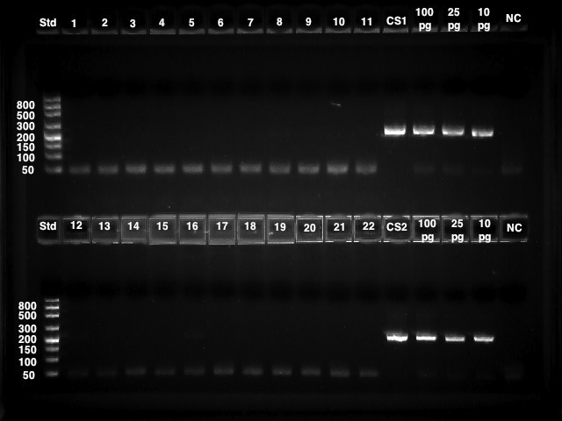

PCR Gel 2
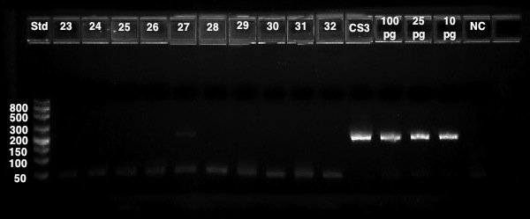

These results show that there is no DNA present on the sample swabs tested. Based on the above data these swabs are considered to be DNA-free and PASS.
DNase Test
Twenty-seven sample swabs were tested for the presence of DNase activity. Two controls, one positive and one negative, were also tested. The swabs and controls were incubated with the 1 KB Plus DNA ladder added as the substrate. The controls contained no swabs; the positive control had the addition of DNaseI while the negative control did not. Aliquots of each reaction were run on a 2.2% double tier Lonza flash gel. If there is DNAse present on the swabs, then the 1 KB Plus DNA ladder from the test reactions should show degradation when compared to the negative control.
DNase Gel
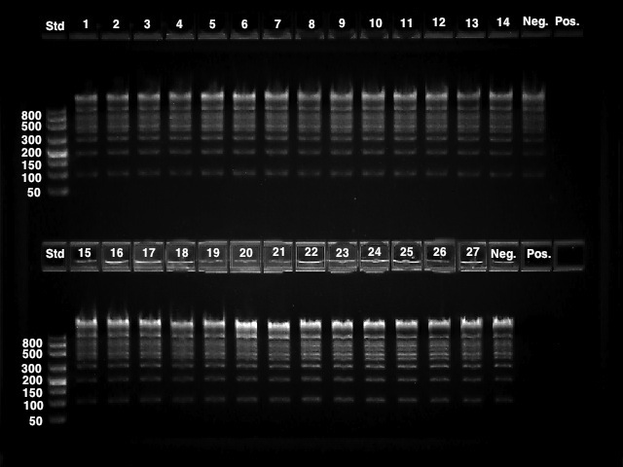

There is no degradation of substrate DNA after incubation with the swabs so these swabs are considered to be DNase-free and PASS.

RNase Test
Twenty-seven swabs were tested for the presence of RNase activity. Two controls, one positive and one negative, were also tested. The swabs and controls were incubated with total RNA added as the substrate. The controls contained no swabs; the positive control had the addition of RNase A while the negative control did not. Aliquots of each reaction were run on the Agilent Bioanalyzer. If there is any RNAse present on the swabs the ribosomal RNA bands should show degradation when compared to the negative control. One chip was run for each region tested, beginning, middle and end.
Beginning Swab Chip
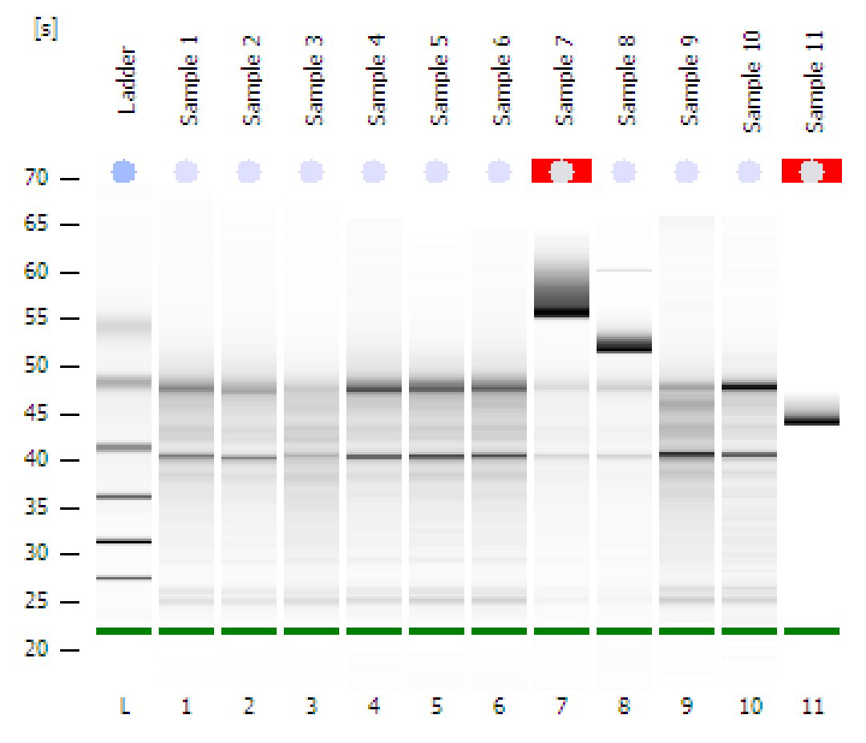

Samples 1-9 are the beginning swab samples, sample 10 is the negative control and sample 11 is the positive control. There are a couple of anomalous bands present however the RNA is not degraded.

Middle Swab Chip
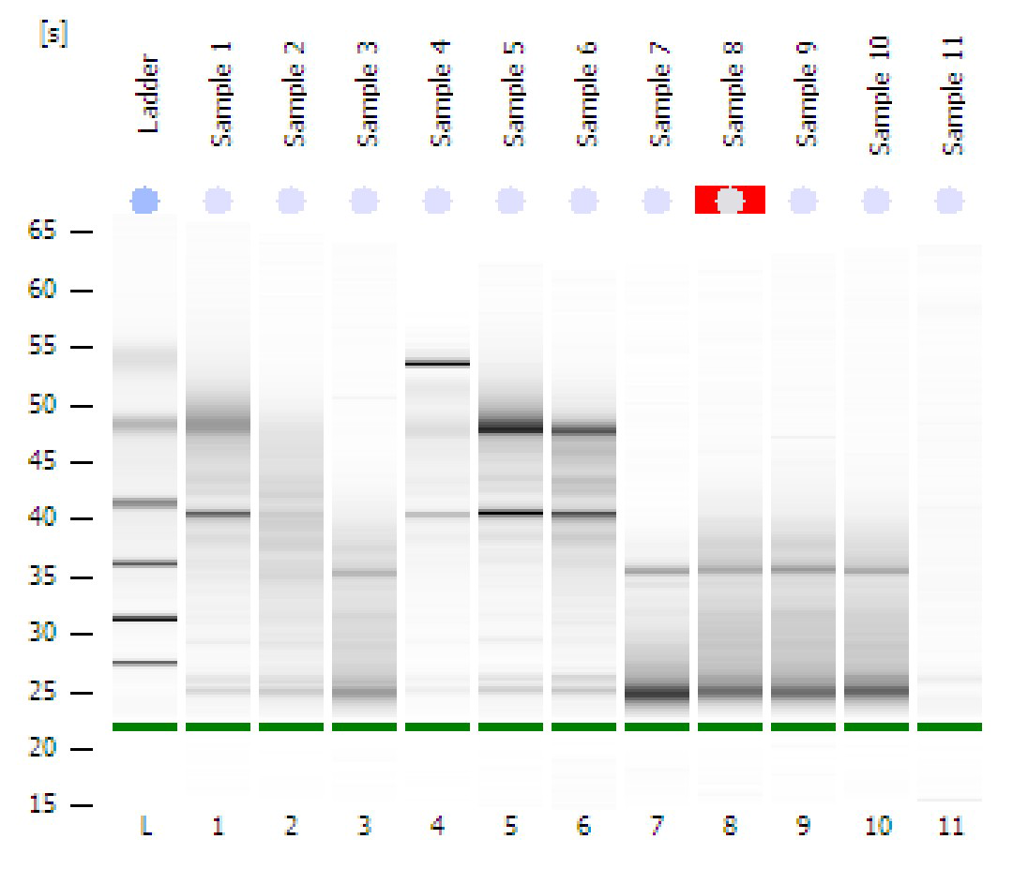

Samples 1-9 are the middle swab samples, sample 10 is the negative control and sample 11 is the positive control. These results show that there appears to be some degradation in several of the samples, including the negative control which was good on the beginning chip. They will be rerun to determine if the degradation is real or an anomaly of this run.

End Swab Chip
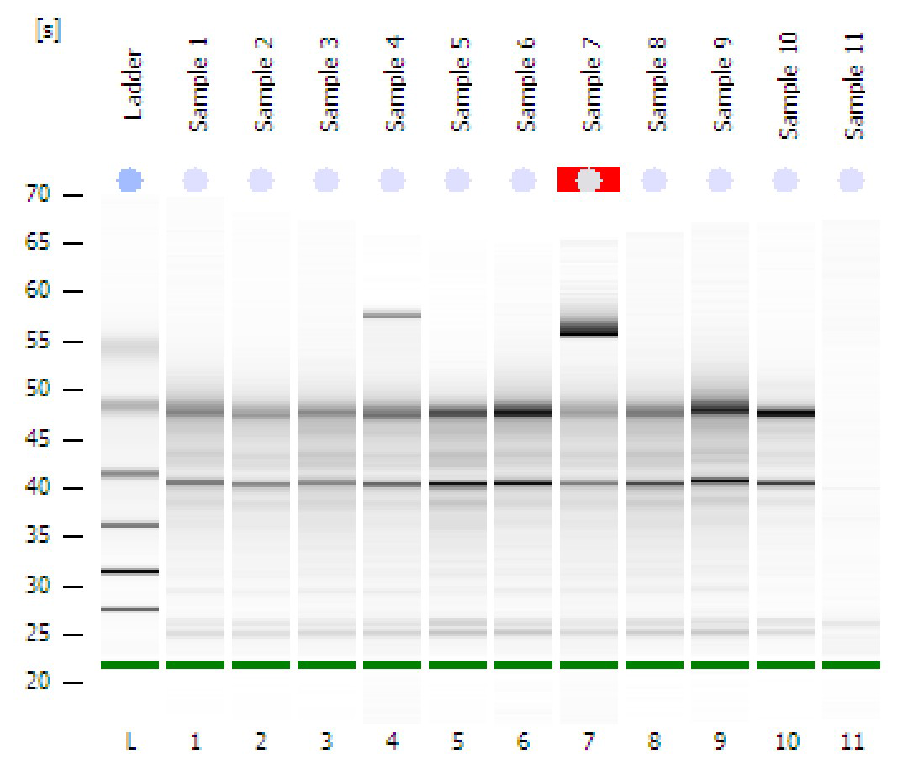
Samples 1-9 are the swab samples, sample 10 is the negative control and sample 11 is the positive control. There are a couple of anomalous bands present however the RNA is not degraded.

Rerun Swab Chip
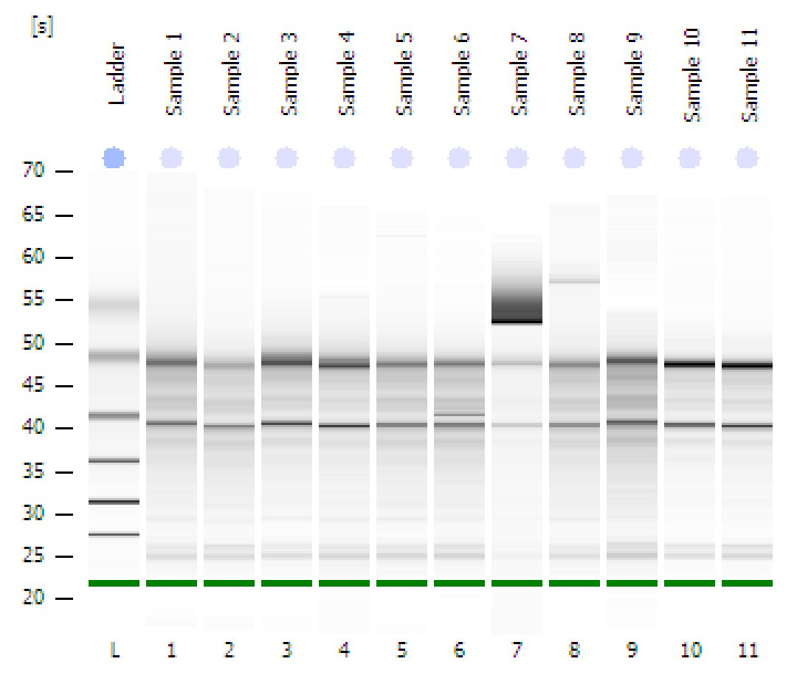
Sample 1- Beginning sample 3 rerun
Sample 2- Beginning sample 9 rerun
Sample 3- Middle sample 2 rerun
Sample 4- Middle sample 3 rerun
Sample 5- Middle sample 7 rerun
Sample 6- Middle sample 8 rerun
Sample 7- Middle sample 9 rerun
Sample 8- Middle sample 7 repeat rerun
Sample 9- Middle sample 8 repeat rerun
Sample 10- Negative control rerun
Sample 11- Negative control repeat rerun

These results show that the apparent degradation was just an anomaly of the middle chip run. Therefore these samples should be considered to be RNase-free and PASS.

